Sinh Viên : Vũ Văn Trọng – 20184206

**ASSIGNMENT 3**

# bubble sort

.data

Arr: .word 9,5,4,6,2,1

.text

.globl main

main:

li $t1,6 # get total number of array elements

# main_loop -- do multiple passes through array

main_loop:

subi $a1,$t1,1 # get count for this pass (must be one less)

blez $a1,main_done # are we done? if yes, fly

la $a0,Arr # get address of array

li $t2,0 # clear the "did swap" flag

jal pass_loop # do a single sort pass

beqz $t2,main_done # if no swaps on current pass, we are done

subi $t1,$t1,1 # bump down number of remaining passes

b main_loop

# everything is sorted

# do whatever with the sorted data ...

main_done:

j end # terminate program

# pass_loop -- do single pass through array

# a0 -- address of array

# a1 -- number of loops to perform (must be one less than array size because

# of the 4($a0) below)

pass_loop:

lw $s1,0($a0) # Load first element in s1

lw $s2,4($a0) # Load second element in s2

bgt $s1,$s2,pass_swap # if (s1 > s2) swap elements

pass_next:

addiu $a0,$a0,4 # move pointer to next element

subiu $a1,$a1,1 # decrement number of loops remaining

bgtz $a1,pass_loop # swap pass done? if no, loop

jr $ra # yes, return

pass_swap:

sw $s1,4($a0) # put value of [i+1] in s1

sw $s2,0($a0) # put value of [i] in s2

li $t2,1 # tell main loop that we did a swap

j pass_next

# End the program

end:

li $v0,10

syscall

* **Bảng text segment**

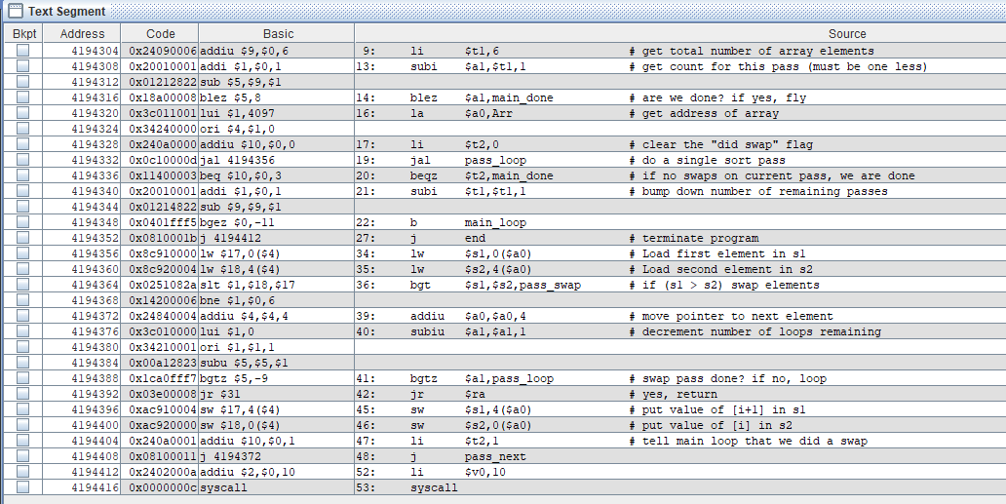

* **Bảng kết quả**

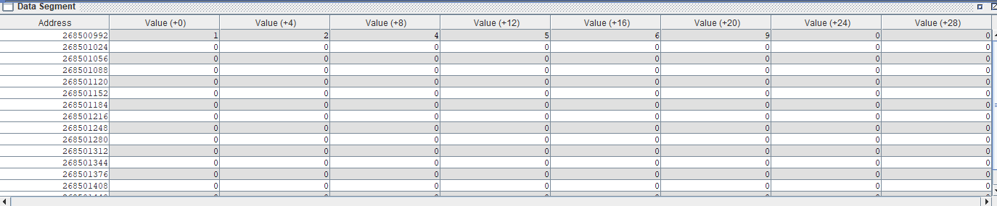

* **Bảng giá trị thanh ghi**

